[Mariska Hargitay Teases Upcoming 'Law & Order: SVU' Reunion With Chris Meloni](https://www.etonline.com/mariska-hargitay-teases-upcoming-law-order-svu-reunion-with-chris-meloni-157233?amp=&__twitter_impression=true&s=09)

**Stacy Lambe‍**

7:05 AM PST, December 3, 2020

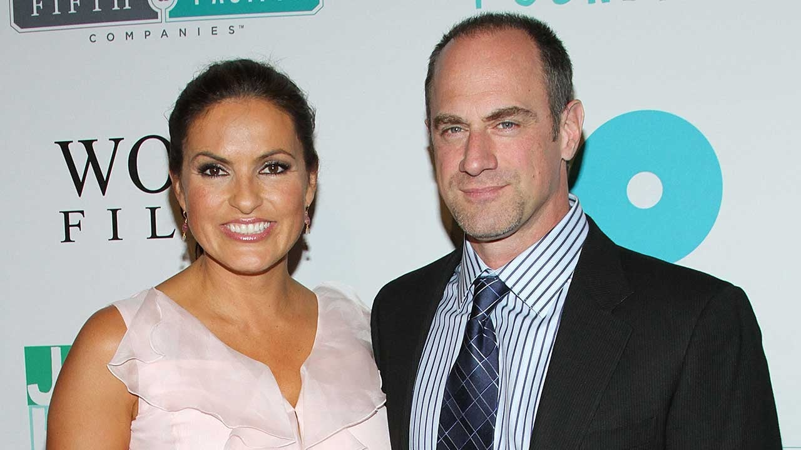

Rob Kim/Getty Images

[**Christopher Meloni**](https://www.etonline.com/people/christopher-meloni)’s return to [***Law & Order: Special Victims Unit***](https://www.etonline.com/tv/law-and-order-svu) is getting closer. His former co-star, Mariska Hargitay, teased their [**anticipated reunion**](https://www.etonline.com/elliot-stabler-is-back-what-chris-melonis-return-means-for-the-law-order-universe-144057) on the NBC drama by posting a photo of Meloni sitting in on a virtual table read.

“Well...that happened…,” Hargitay, who plays Captain Olivia Benson, captioned a photo of a massive Zoom meeting featuring the current cast of *SVU*, writers and producers as well as Meloni, who played Elliot Stabler for 12 seasons prior to leaving the series.

On Twitter, showrunner and executive producer Warren Leight posted a similar image. “Well, we had a pretty good read-thru,” he wrote, confirming that the virtual reunion was officially (finally) in preparation for the long awaited reunion between Benson and Stabler.

Meloni is expected to reprise his role [**sometime in season 22**](https://www.etonline.com/law-order-svu-season-22-coronavirus-elliot-stabler-preview-155899) ahead of his return to the *Law & Order* universe as the lead of a new spin-off, *Law & Order: Organized Crime*. Production on the new series, however, [**was delayed**](https://www.etonline.com/law-order-svu-to-deal-with-this-moment-while-organized-crime-delayed-until-2021-152394) due to the coronavirus pandemic and staff changes, pushing its premiere to the spring and [**postponing his reunion**](https://www.etonline.com/christopher-meloni-returning-to-svu-in-season-22-premiere-ahead-of-new-series-145822) with Hargitay.

But that didn’t stop the *SVU* team from preparing for his return to his old squad room to reunite with some familiar faces. “As soon as his show starts, we’ve already got a crossover episode written,” Ice-T, who plays Sgt. Fin Tutuola, [**told ET**](https://www.etonline.com/law-order-svu-season-22-coronavirus-elliot-stabler-preview-155899) ahead of the season 22 premiere, adding, “I can’t wait to see Chris again.”

The actor noted, “It’s always a treat when [anyone] comes back every time… It’s a family.”

RELATED CONTENT:

['Law & Order: SVU': What's in Store for Season 22](https://www.etonline.com/law-order-svu-season-22-coronavirus-elliot-stabler-preview-155899)

[Wentworth Miller Returning to 'Law & Order: SVU' in Season 22](https://www.etonline.com/wentworth-miller-returning-to-law-order-svu-in-season-22-156510)

[Chris Meloni on 'Maxxx' and Returning to the 'Law & Order' Universe (Exclusive)](https://www.etonline.com/chris-meloni-on-his-law-order-return-maxxx-and-love-for-eccentric-characters-exclusive-150161)

[**Chris Meloni Talks Reuniting With ‘Law & Order: SVU’ Co-Star Mariska Hargitay (Exclusive)**](https://www.etonline.com/media/videos/chris-meloni-talks-reuniting-with-law-order-svu-co-star-mariska-hargitay-exclusive)